Copy the isometric drawings. Add shading. Name: _________________________
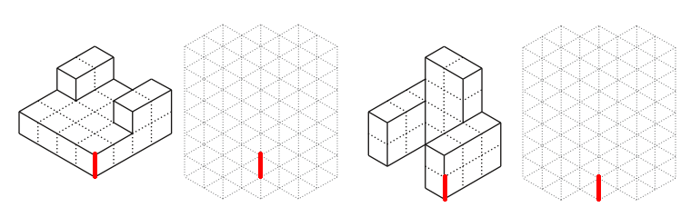
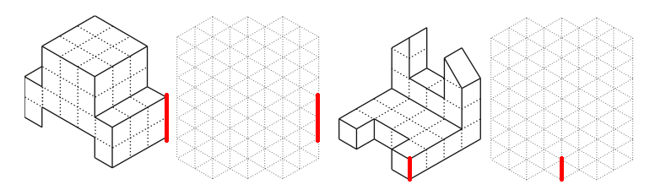
Cardboard Chair Project
Criteria | Constraints
Create an isometric drawing of your idea for the cardboard chair and then copy the designs of 2 other students. Describe what features are good/bad in each design

Your design: Good features Other design 1 : Good features Other design 2: Good features

Suggested improvements Suggested improvements Suggested improvements

